Lucrarea de laborator nr. 3

Samciucov Valentin

Minimizarea funcţiilor logice şi elaborarea schemei electrice principiale

# Scopul lucrării:

1. Obţinerea deprinderilor de minimizare a funcţiilor logice.
2. Obţinerea deprinderilor de construire a schemelor electrice principiale.

# Experimentul nr. 1. Proiectarea schemei electrice numerice principiale

f(a,b,c,d,e,f) = ∑(7, 8, 9, 10, 11, 12, 13, 14, 15, 16, 17, 18, 19, 21, 22, 23, 24, 25, 26, 27,

28, 29, 32, 33, 34, 35, 36, 37, 38, 39, 40, 41, 42, 43, 44, 45, 46, 48, 49, 50, 51, 52, 53, 54)

|  |  |  |  |  |  |  |  |  |  |  |
| --- | --- | --- | --- | --- | --- | --- | --- | --- | --- | --- |
| *def/abc* | *000* | *001* | *011* | *010* | *110* | *111* | | *101* | *100* | *abc/def* |
| *000* |  | 1 | 1 | 1 | 1 |  | | 1 | 1 | *000* |
| *001* |  | 1 | 1 | 1 | 1 |  | | 1 | 1 | *001* |
| *011* |  | 1 | 1 | 1 | 1 |  | | 1 | 1 | *011* |
| *010* |  | 1 | 1 | 1 | 1 |  | | 1 | 1 | *010* |
| *110* |  | 1 |  | 1 | 1 |  | | 1 | 1 | *110* |
| *111* | 1 | 1 |  | 1 |  |  | |  | 1 | *111* |
| *101* |  | 1 | 1 | 1 | 1 |  | | 1 | 1 | *101* |
| *100* |  | 1 | 1 |  | 1 |  | | 1 | 1 | *100* |
| *def/abc* | *000* | *001* | *011* | *010* | *110* | *111* | | *101* | *100* | *abc/def* |
| k0 = c  k1 = b  k3 = a  k4 = a  k5 = b | | | | | | | k6 = ae  k7 = be  k8 = e  k9 = c  k10 = bdf  k11 = a  k12 = def | | | | |

f(a,b,c,d,e,f) = $\overline{a}\overline{b}$ c + $\overline{a}$ b $\overline{d}$ + a $\overline{b}\overline{d}$ + a $\overline{b}\overline{e}$ + b $\overline{c}\overline{d}$ + a $\overline{b}$ e $\overline{f}$ + b $\overline{c}$ e $\overline{f}$ + $\overline{a}b\overline{c}$ e + $\overline{a}$ c $\overline{e}$ + b $\overline{c}$ d $\overline{e}$ f + a $b\overline{c}\overline{e}$ + $\overline{b}\overline{c}$ def

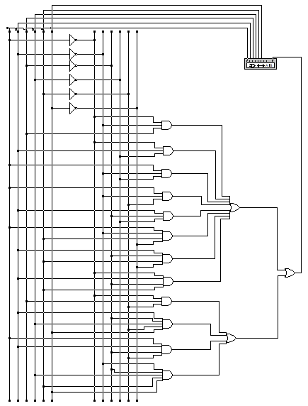

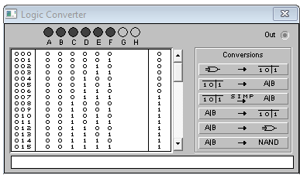

Fig.1. Schema electrica, construita conform functiei logice minimizate

**Experimentul nr. 2.** **Elaborarea schemei electrice logice din elemente ŞI-NU**

f(a,b,c,d,e,f) = $\overline{a}\overline{b}$ c + $\overline{a}$ b $\overline{d}$ + a $\overline{b}\overline{d}$ + a $\overline{b}\overline{e}$ + b $\overline{c}\overline{d}$ + a $\overline{b}$ e $\overline{f}$ + b $\overline{c}$ e $\overline{f}$ + $\overline{a}b\overline{c}$ e + $\overline{a}$ c $\overline{e}$ + b $\overline{c}$ d $\overline{e}$ f + a $b\overline{c}\overline{e}$ + $\overline{b}\overline{c}$ def = $\overset{̿}{\overline{a}\overline{b}c + \overline{a}b\overline{d} + a\overline{b}\overline{d} + a\overline{b}\overline{e} + b\overline{c}\overline{d} + a\overline{b}e\overline{f} + b\overline{c}e\overline{f} + \overline{a}b\overline{c}e + \overline{a}c\overline{e} + b\overline{c}d\overline{e}f + ab\overline{c}\overline{e} + \overline{b}\overline{c}def }$

= $\overline{\overline{\overline{a}\overline{b}c} \overline{\overline{a}b\overline{d}} \overline{a\overline{b}\overline{d}} \overline{a\overline{b}\overline{e}} \overline{b\overline{c}\overline{d}} \overline{a\overline{b}e\overline{f}} \overline{b\overline{c}e\overline{f}} \overline{\overline{a}b\overline{c}e} \overline{\overline{a}c\overline{e}} \overline{b\overline{c}d\overline{e}f} \overline{ab\overline{c}\overline{e}} \overline{\overline{b}\overline{c}def}}$

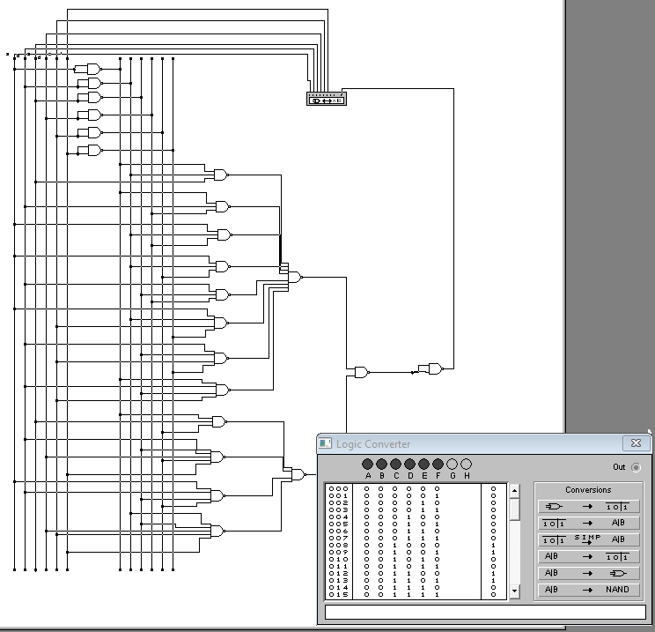

**Experimentul nr. 3.** **Elaborarea schemei electrice logice din elemente SAU-NU**

f(a,b,c,d,e,f) = $\overline{a}\overline{b}$ c + $\overline{a}$ b $\overline{d}$ + a $\overline{b}\overline{d}$ + a $\overline{b}\overline{e}$ + b $\overline{c}\overline{d}$ + a $\overline{b}$ e $\overline{f}$ + b $\overline{c}$ e $\overline{f}$ + $\overline{a}b\overline{c}$ e + $\overline{a}$ c $\overline{e}$ + b $\overline{c}$ d $\overline{e}$ f + a $b\overline{c}\overline{e}$ + $\overline{b}\overline{c}$ def = $\overset{̿}{\overline{a}\overline{b}c }$ + $\overset{̿}{\overline{a}b\overline{d} }$ + $\overset{̿}{\overline{a}b\overline{d}}$ + $\overset{̿}{a\overline{b}\overline{e}}$ + $\overset{̿}{b\overline{c}\overline{d}}$ + $\overset{̿}{a\overline{b}e\overline{f}}$ + $\overset{̿}{b\overline{c}e\overline{f}}$ + $\overset{̿}{\overline{a}b\overline{c}e }$ + $\overset{̿}{\overline{a}c\overline{e}}$ + $\overset{̿}{b\overline{c}d\overline{e}f }$ + $\overset{̿}{ab\overline{c}\overline{e}}$ + $\overset{̿}{\overline{b}\overline{c}def }$ =

= $\overline{a + b + \overline{c} }$ + $\overline{a + \overline{b} + d}$ + $\overline{a + \overline{b} + d}$ + $\overline{\overline{a} + b + e}$ + $\overline{\overline{b} + c + d}$ + $\overline{\overline{a} + b + \overline{e} + f}$ + $\overline{\overline{b} + c + \overline{e} + f}$ + $\overline{a + \overline{b} + c + \overline{e} }$ + $\overline{a + \overline{c} + e}$ + $\overline{\overline{b} + c + \overline{d} + e + \overline{f}}$ + $\overline{\overline{a} + \overline{b} + c + e}$ + $\overline{b + c + \overline{d} + \overline{e} + \overline{f} }$ = $\overset{̿}{\overline{a + b + \overline{c} } + \overline{a + \overline{b} + d} + \overline{a + \overline{b} + d} + \overline{\overline{a} + b + e} + \overline{\overline{b} + c + d} + \overline{\overline{a} + b + \overline{e} + f} + }$

$$\overset{̿}{ + \overline{\overline{b} + c + \overline{e} + f} + \overline{a + \overline{b} + c + \overline{e} } + \overline{a + \overline{c} + e} +}$$

$$\overset{̿}{+ \overline{\overline{b} + c + \overline{d} + e + \overline{f}} + \overline{\overline{a} + \overline{b} + c + e} + \overline{b + c + \overline{d} + \overline{e} + \overline{f} }}$$

